Cloud Computing Architecture

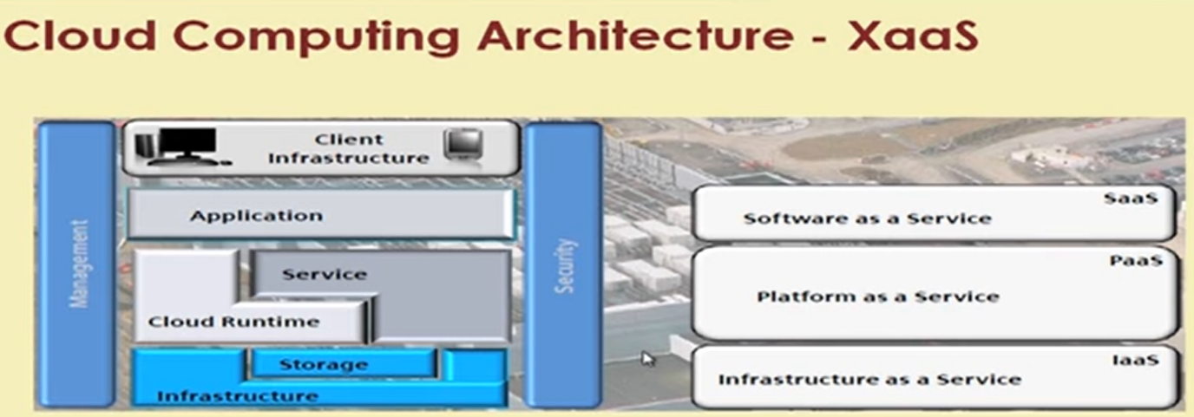

Management and Security are required across all the layers of the Architecture.

Even Microsoft Azure and AWS also have vertical stack.

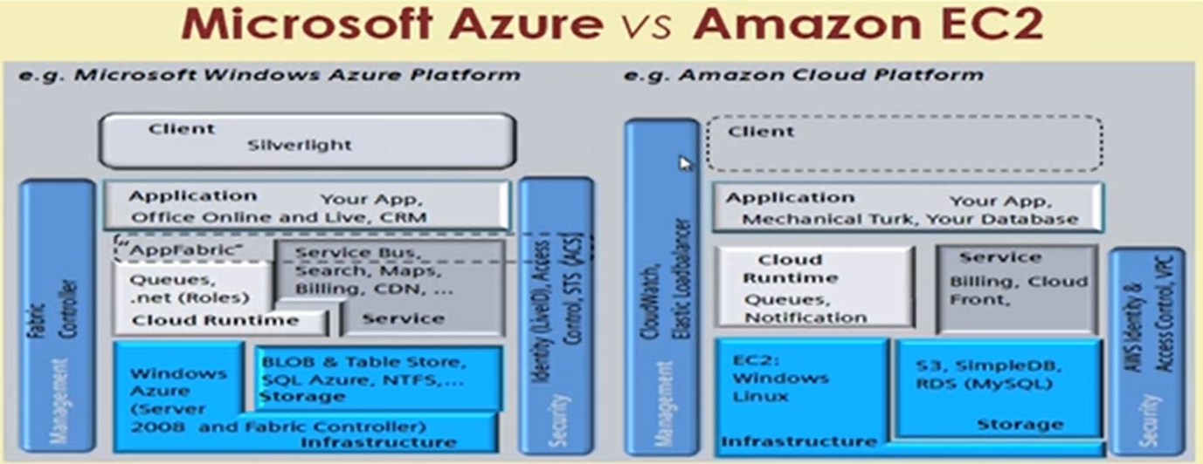

**Architecture of Elasticity:**

Vertical Vs Horizontal Scale

**Service Models:**

1. Business Process As A Service (BPaaS)
2. Software As A Service (SaaS)
3. Platform As A Service (PaaS)
4. Infrastructure As A Service (IaaS)

Business Process As A Service (BPaaS):

This is matters more for organizations. It is much more than a SaaS. Helpful for co-ordinating different businesses processes. It is even possible to use 2 different processes running on 2 different cloud providers.

**Classical Vs Evergreen IT:**

Coupling b/w layers of architecture is more Classical IT. Evergreen IT is to have loosely coupled layers of Architecture.